**TIES**

**Red Tag Tool Use and Safety Guidelines**

University of the Pacific

2016

**Carbide 3D Desktop CNC Milling Machine**:

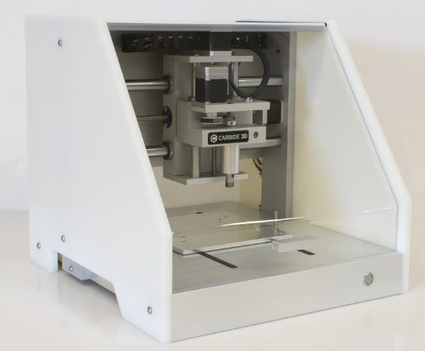

* Always wear safety glasses when the Nomad 883 is in operation
* Always keep the protective door in closed while the Nomad 883 is in operation
* Cutters are sharp and should be handled with care
* Never reach into the machine while it is running
* Use Carbide Motion software to control the machine
* Use MeshCAM software (on computer connected to mill) to prepare tool path
* Complete the tutorials (<http://carbide3d.com/docs>) before using the machine
* .stl files created in other software (ie SolidWorks) can be imported into meshCAM
* You must secure the workpiece to the table or in the vice.
* Be sure to use a sacrificial piece under workpiece or set the depth of cut to less than the workpiece to avoid milling the machine table or vice.
* X, Y, and Z zero setpoint needs to be calculated and entered in software
* Tool length must be appropriate for the depth of cut and to clear the vice etc.
* Choose the correct spindle speed and feed rate for the material being machined
* Materials are limited to wood, plastic, and non-ferrous metals
* Stock dimensions are limited to 8” by 8” by 3”
* Two sided machining needs to take into consideration zero setpoint for 2nd side.

**CNC Router:**

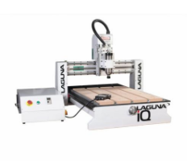

* Dust collection system needs to be connected and running
* Ensure coolant is running to the spindle before starting the machine
* Wear hearing protection during extended periods of use
* Never reach into or around the spindle gantry while it is in operation
* Use the emergency stop button on the control panel if anything goes wrong
* You must secure the workpiece to the table
* Choose spindle speeds and feed rates appropriate to material being cut
* Two sided machining requires forethought about re-finding 0 point for X, Y, and Z axis
* Use Vectric software to prepare the toolpaths
* Be sure to reset the X, Y, and Z zero setpoint before each job
* Tool length/ tool touch off puck needs to be mounted and offsets to workpiece calculated
* Material selection is currently limited to wood and plastic, aluminum may be cut after discussion with shop staff technician
* Stock dimensions are 48” by 48” by 6”
* 4th axis spindle is available for lathe or multi sided techniques

**Wood Lathe:**

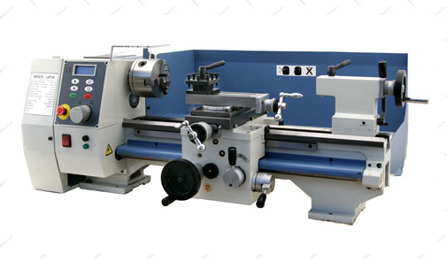

* Never leave the chuck key in the lathe.
* You must not wear gloves
* Lathe chips can be hot and sharp, do not use your hands to remove or brush away chips.
* Turn the lathe off before adjusting the tool bit height etc.
* Check that all locking devices on the tailstock and tool rest assembly (rest and base) are tight before operating the lathe.
* Always check the speed of the material to be cut and calculate appropriate spindle speed. Make sure the workpiece is secured before starting the lathe
* Stand to the side when starting the lathe just in case the piece comes loose
* NEVER force the cutting tool into the workpiece
* Secure any loose clothing to avoid getting caught and pulled into rotating parts

**Benchtop Injection Molding Machine:**

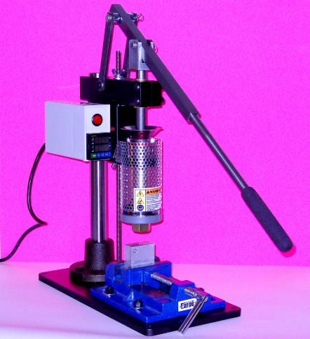

* Never operate the machine at temperatures above 490F as this will damage the machine
* Molten plastic is very hot and will stick to you and keep burning. Rinse an affected area in cold water immediately.
* Always wear safety glasses when running the machine
* Always wear heat insulating (leather etc.) gloves when operating the machine and when handling molds. Never touch any metal parts on the machine
* Set the temperature controller to the appropriate temperature for the plastic being injected
* Never leave the heater on when the machine is unattended or not being operated. Some plastic materials can degrade and emit harmful gasses
* Never purge the machine without supporting the nozzle
* Ensure the plastic pellets are dry before putting into machine

**Power Hand Saw (aka Skil Saw):**

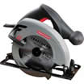

* You must wear a Face Shield as well as Safety Glasses when operating the Skil saw.
* NEVER disable the blade safety guard, or use the saw if there any problems with the safety guard.
* Unplug the saw or remove the battery pack before handling or changing the blade or adjusting the table angle or depth of cut.
* Select the proper blade for the cut to be made. Check the blade to be free of cracks or nicks, and that it is sharp.
* Limit the blade extension to 1/4 inch below the piece being sawed.
* Support the wood being cut so that it doesn’t “pinch” the blade and stop the saw, or doesn’t break off near the end of the cut.
* Hold the saw firmly with both hands before turning on the power.
* Feed the saw at a moderate rate; too slow of a feed rate will cause burning of the wood, too rapid a rate will produce a rough splintery surface.
* Stand to the side of the saw in case it “kicks back”.
* Be aware of what’s under the material you’re cutting! (i.e. fingers, edge of the table, metal saw horses, etc.)

#### **Belt and Disc sander:**

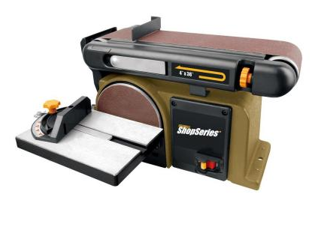

* Check the sanding belt or disk to make sure it is in good condition and not torn. The Shop Tech will replace worn belts or disks for you.
* Keep fingers and hands clear of the moving or rotating surface.
* Hold the work-piece securely and use only moderate pressure.
* Sand only on the downward motion side of the Disk Sander.
* Move the work-piece side to side on the sanding surface to prevent rapid wear of the belt or disc

#### **Miter Saw:**

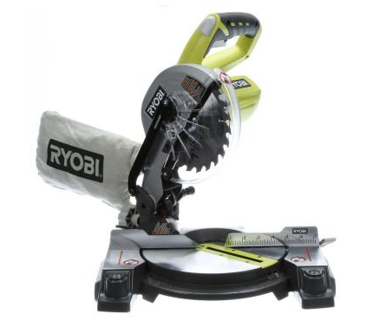

* You must ask the Tech’s permission to use the compound miter saw.
* Unplug the battery from the machine before handling or changing the blade.
* Select the proper blade for the cut to be made. Check the blade to be free of cracks or nicks, and that it is sharp. Ask a Tech to change the blade for you, only a Tech may change the blade.
* Secure the work piece with the supplied hold down levers.
* Feed the saw into the work piece at a moderate rate, but not so fast the motor slows down.
* When cutting long pieces on the compound miter saw, support the work.
* Make sure the compound miter saw has an operational blade guard,
* You may not cut any work-piece on the compound miter saw that is less than 6 inches in length.
* The compound miter saw is for cutting wood or plastic materials only!

#### **Angle/disc Grinder or Sander:**

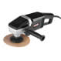

* You must wear a Face Shield as well as Safety Glasses when using a disc grinder.
* Carefully inspect the entire disc or blade before using. Don’t use if cracked, chipped, etc., it could fly apart at high speed explosively.
* Always be aware of the direction you are throwing the stream of sparks/dust/chips. It is your responsibility to be sure you are not throwing sparks on other people, in the vicinity of those without eye protection, or on potentially flammable items.
* Ensure the tool has come to a complete stop before laying it down.

**Drill Press:**

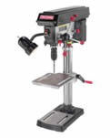

* Use a center punch to help locate the hole to be drilled in the correct place.
* Select the correct speed for the material and size drill being used.
* REMOVE THE CHUCK KEY IMMEDIATELY AFTER TIGHTENING OR REMOVING A DRILL! Leaving it in creates a high risk of injury or damage.
* All work must be held securely for drilling by using either a drill vise or C-clamps. A work-piece that moves when being drilled can break the drill, injure the operator and destroy itself.
* Don’t drill into the vise or table. Use wood under “through” holes.
* Hold round stock securely with a “Vee block” in a vise.
* Large work-pieces must be set firmly against the left side of the drill press column so that if the drill grabs, it cannot spin the work-piece and cause injury to the operator or others.
* If the drill grabs the work piece and it is yanked loose of the clamps and begins to spin, maintain downward pressure with the press and turn off the power. Do not retract the drill as this would allow the work-piece to be thrown from the press and may cause serious injury.
* Hands are to be kept clear of the revolving spindle, chuck, drill and chips.
* Always ease up on the feed or drill pressure as the drill begins to break through the work-piece. Heavy feed pressure will cause the drill to dig in, and could damage the material being drilled, break the drill, or cause the work-piece to spin.
* Drilling soft materials such as brass, cooper, or plastic is done with a drill ground differently than drills used for steel.
* When drilling large holes drill a pilot hole with a small drill such as 1/8 inch and then step up in sizes to prevent drill chatter.
* Be sure the drill press is stopped before removing the work-piece, or clearing chips or cuttings.

**Bandsaw - Vertical:**

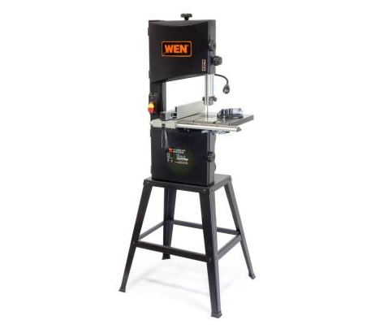

* When feeding a work-piece into the bandsaw blade your hands should not be in line with the blade in case you slip or lose balance.
* CAUTION: Stand to one side while doing power-on testing of blade tracking. Should the blade come off the wheels or break it could cause serious injury.
* Adjust the blade guides and rollers properly, and adjust the speed. The upper saw guide should be about 1/4 inch above the work-piece.
* Check the work-piece to be sure it is free of debris (i.e. rocks, tool bits, nails).
* Plan the cut to prevent backing out of a cut, as this will pull the blade off the wheels. Make relief cuts as needed for tight radius areas.
* Holding the work-piece firmly, start it gently, feed it at a moderate rate.
* Use a push stick when sawing small or difficult to hold pieces.
* A minimum of three teeth must be engaged in the work-piece at all times or the teeth will be torn off of the blade.
* Hold round stock securely with a “Vee block” in a vise.
* Note:This bandsaw is not intended for metal, blades are available to cut wood or plastics.

**Bench Grinder:**

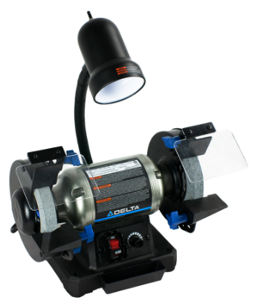

* When feeding a work-piece into the grinding wheel it should be braced against the tool rest.
* Never point a material being ground upward into the wheel, it will kick back at you.
* Do not grind on the side of the wheel
* ALL SAFETY GUARDS MUST BE IN PLACE AND OPERATIONAL!